A Mini Project report

On

**“Live BMTC Bus Tracking System”**

Submitted in partial fulfillment of the requirement for

**Master of Computer Application**

Of

**Visvesvaraya Technological University**

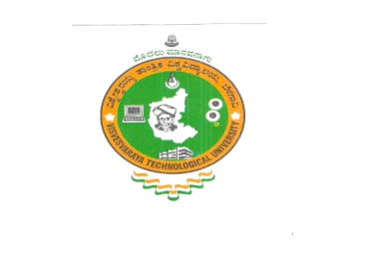

**2014-2015**

Submitted by

**VIJAY KUMAR N 1RX13MCA53**

Under the guidance of

**Dr. N.P. Kavya**

H O D

Department of MCA

RNSIT, Bengaluru



**Department of MCA**

**RNS Institute of Technology**

**Channasandra, Bengaluru – 560061**

A Mini Project report

On

**“Live BMTC Bus Tracking System”**

Submitted in partial fulfillment of the requirement for

**Master of Computer Application**

Of

**Visvesvaraya Technological University**



**2014-2015**

Submitted by

**VIJAY KUMAR N**

**1RX13MCA53**

Under the guidance of

**Dr. N.P.Kavya**

H O D

Department of MCA

RNSIT, Bengaluru



**Department of MCA**

**RNS Institute of Technology**

**Channasandra, Bengaluru – 560061**